**BANK LOAN REPORT QUERY DOCUMENT**

1. ***BANK LOAN REPORT | SUMMARY***

* **KPI’s:**

**TOTAL LOAN APPLICATION**



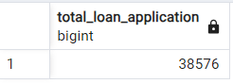

**MTD LOAN APPLICATION**

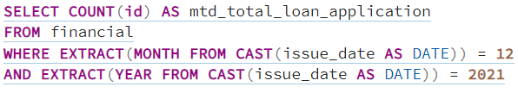

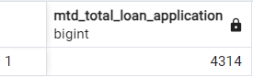

**PMTD Loan Applications**

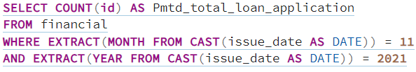

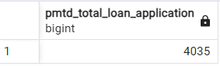

**Total Funded Amount**



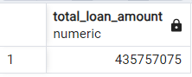

**MTD Total Funded Amount**

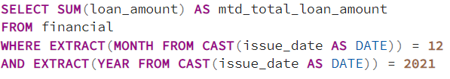

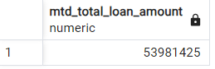

**PMTD Total Funded Amount**

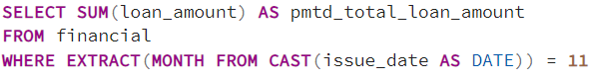

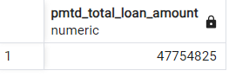

**Total Amount Received**



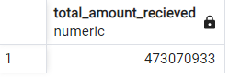

**MTD Total Amount Received**

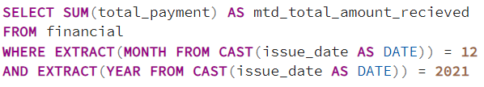

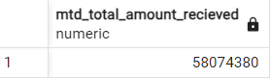

**PMTD Total Amount Received**

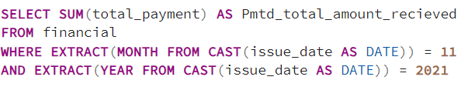

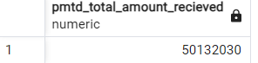

**Average Interest Rate**



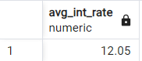

**MTD Average Interest Rate**

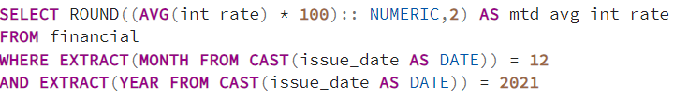

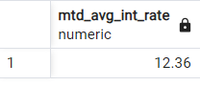

**PMTD Average Interest Rate**

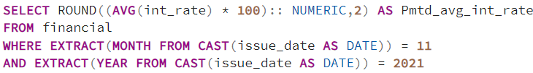

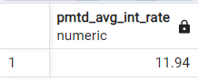

**Avg DTI**



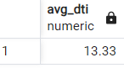

**MTD Avg DTI**

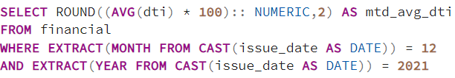

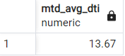

**PMTD Avg DTI**

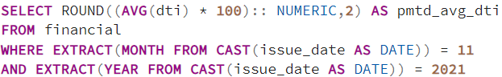

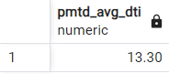

* **GOOD LOAN ISSUED :**

**Good loan percentage**

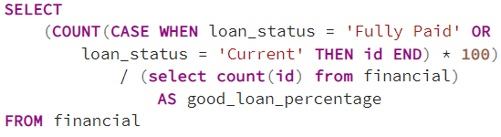

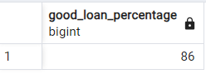

**Good Loan Applications**

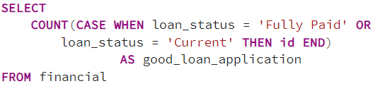

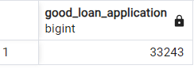

**Good Loan Funded Amount**



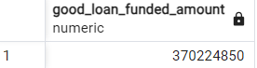

**Good Loan Amount Received**



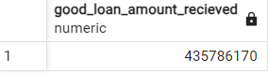

* **BAD LOAN ISSUED :**

**Bad Loan Percentage**

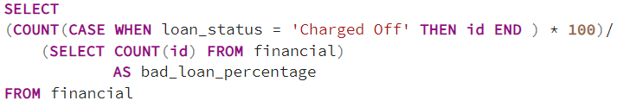

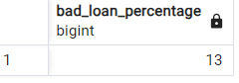

**Bad Loan Applications**

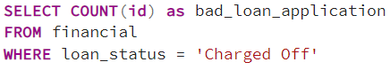

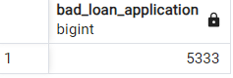

**Bad Loan Funded Amount**

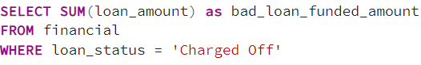

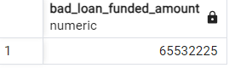

**Bad Loan Amount Received**

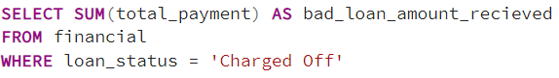

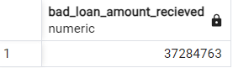

* **LOAN STATUS**

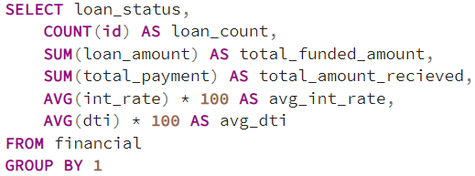

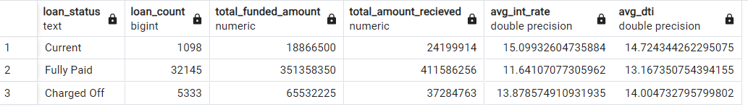

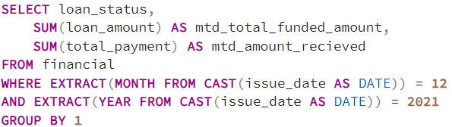

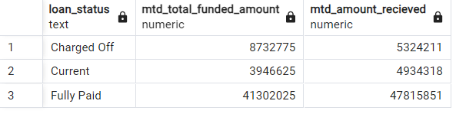

1. ***BANK LOAN REPORT | OVERVIEW***

* **MONTH**

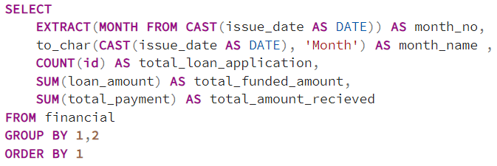

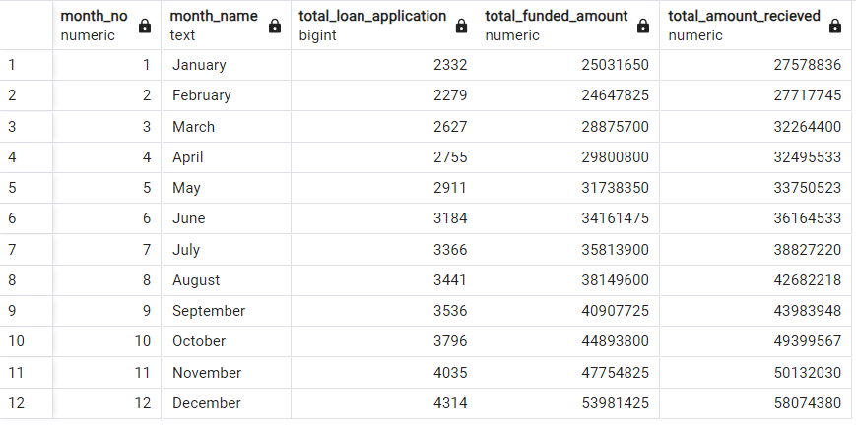

* **STATE**

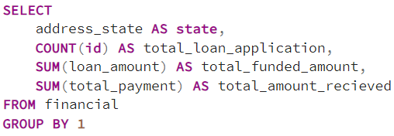

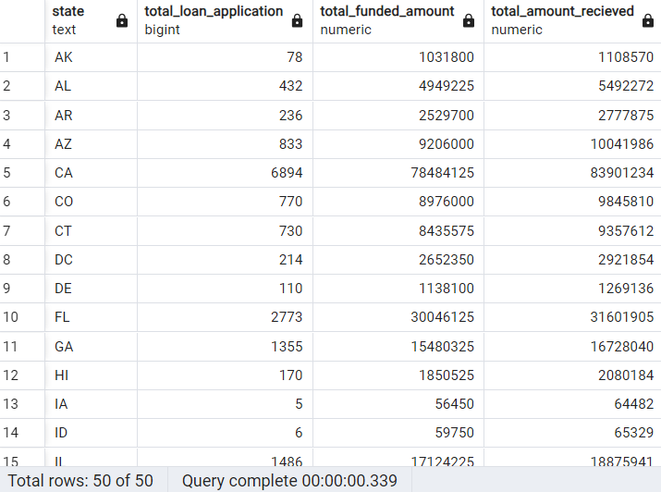

* **TERM**

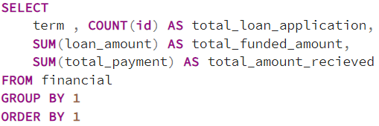

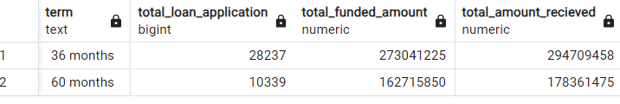

* **EMPLOYEE LENGTH**

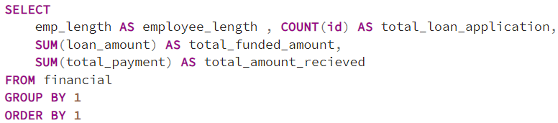

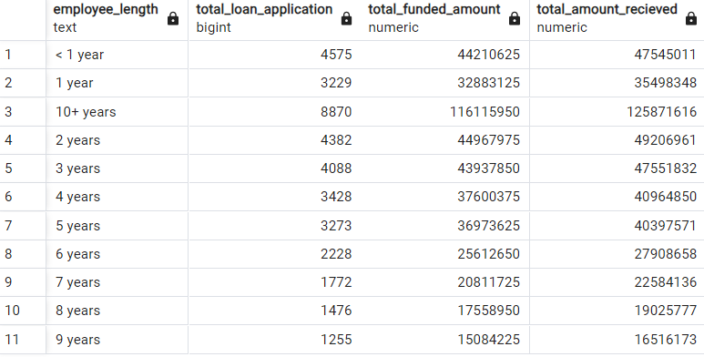

* **PURPOSE**

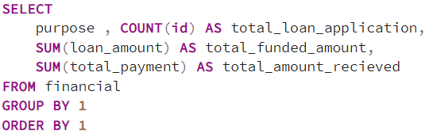

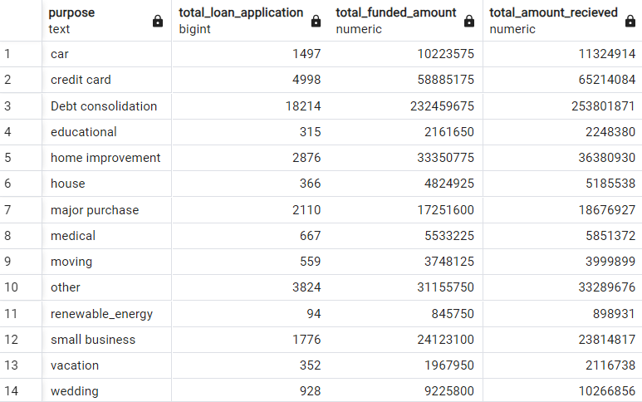

* **HOME OWNERSHIP**

